Kamiak Prom Corsages & Boutonnieres
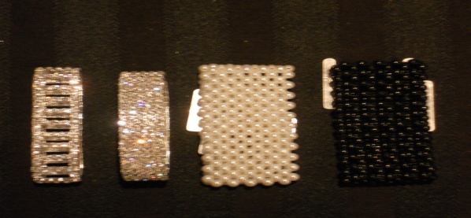
Kamiak Prom Special. ONE order per order form. Please select:
⃣ 1 Wrist corsage & matching boutonniere, $30.00
ordered, boxed & paid for together with ONE check
⃣ 1 Wrist corsage $25.00 (Three styles to choose from!)
⃣ 1 Boutonniere $10.00 (Two styles to choose from!)
⃣ Wristlett upgrade to bracelet style. Add. $10
Choose ⃣ Black Pearl ⃣ White Pearl ⃣ Rhinestone
Ring Around the Rose is a studio florist specializing in wedding and event flowers.
(I am also Garrett Britton’s mom!)
Please give your order to Garrett with your check/cash by Monday May 5, 2014. You can staple a fabric or color sample to this order if you have one OR You can email me a picture of your dress with your order and I will create a custom design to match your ensemble. Lbritton2@msn.com Please include “Prom” in the subject title
Important information!
I can promise white flowers with your choice of color for ribbon. I may get some other colors as well (such as red roses, pink orchids, etc.) so fill in the details below & If I can get a colored flower in your color, I will surprise you with a custom design!
1. White orchid 2. Baby Rose 3. Rose & Orchid 4. Baby Rose 5. Orchid
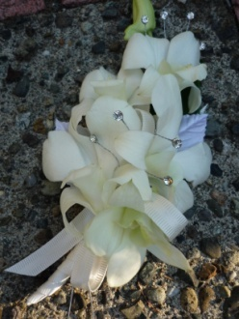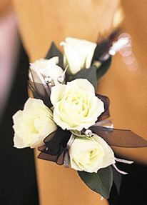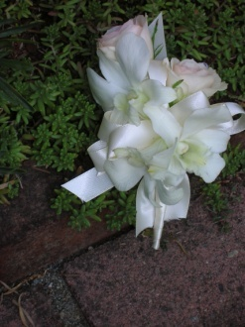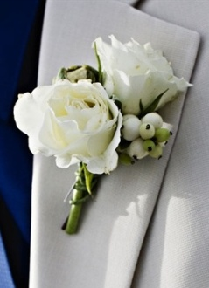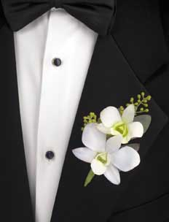
Please check all available information below so I can create a perfect match for you!

Corsages

1. Choose your flower style above. #1, #2 or #3
⃣ 1. All white dendrobium orchids OR
⃣ 2. All white baby sweetheart roses OR
⃣ 3. White dendrobium orchid AND white baby sweetheart roses
⃣ OR WOW ME!
Designer’s choice to match; let me decide!
2. Dress color: _________________________________
(Be specific! Baby blue, aqua blue, teal You can attach fabric or color sample to this order if you have one.)
Circle if there are any of the following on the dress
(pearls) (sequins) (rhinestones) or any details that are important______________________________________
3. Check which ribbon color you prefer
⃣ metallic silver ⃣ metallic gold ⃣ black velvet
⃣ my choice to match dress OR write in a custom color
Here:_________________________________________

Deadline to order May 5 2014
All designs must be picked up in the Kamiak circle between 9am- 10am Saturday May 17, 2014

Boutonnieres

1. Choose your flower style above. #4, #5
⃣ 4. Two white sweetheart roses
⃣ 5. Two white dendrobium orchids

⃣ OR Designers choice to match: Let me decide

2. Tux color ___________________________________
Vest/tie color__________________________________
3. Check which ribbon color you prefer
⃣ metallic silver ⃣ metallic gold ⃣ black velvet
⃣ my choice to match dress OR write custom color Here:____________________________________
Please check method of payment
All orders prepaid by ⃣ CASH ⃣ CHECK ⃣ PAYPAL
PAYPAL ORDERS HAVE $2.00 service charge
Make checks payable to Lorie Britton
CHECK # _____________email me for paypal payments 9.5% sales tax included in total.
Your Name____________________________________
Your Home Phone_______________________________
Your Cell Phone________________________________
Email (for confirmation) __________________________

To see samples of my work visit my website at www.ringaroundtherose.com 425-745-6209
Call or email if you have any questions or need help filling out your order!

